**MATLAB bonus competition**

**Rules:**

1. Assignment should be done in pairs.
2. Assignment is meant for independent learning and **you are not allowed to consult any staff member about technical guidance or problems**; questions about the assignment requirements please refer to Neta Stern only.
3. Each member of the first three pairs to submit code which meets all of the requirements will receive a **5-point increase** in the exam grade.
4. Please submit your code and ID numbers to Neta Stern.

**Instructions:**

You are required to create a figure using MATLAB GUIDE infrastructure. The figure should contain 3 parts:

1. An **original** text containing a rhymed 5-line English poem / song (should contain at least one rhyme).
2. A button. When the button is pressed, the table in the bottom of the figure should be filled.
3. The table should contain two columns. After pressing the button in section 2, the left column should contain all the 26 ABC letters, and the right column should be filled with the number of occurrences of each letter – both in uppercase and in lower case – in your song. For example, if your song contains the character 'a' 4 times and the character 'A' 2 times, the cell next to the letter 'a' should contain the number 6.
4. The design of the form is of no importance. It only matters that all song lines are separate, button can be pressed, and table data can be viewed (possibly using a scroller).

**An example solution:**

The figure before pressing the button:

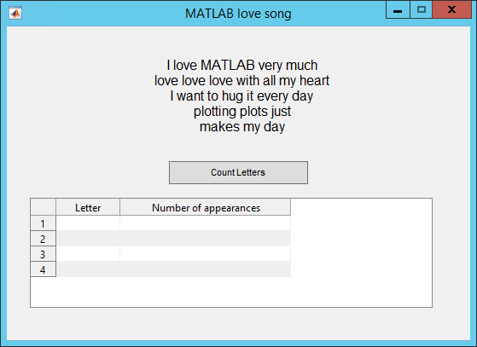

The figure after pressing the button:

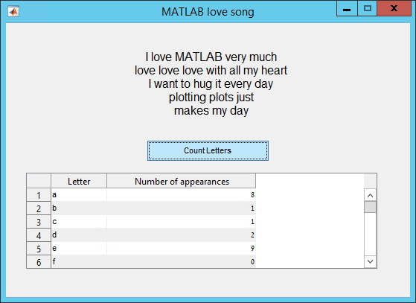

Notice that if we scroll down to the 'm' row in this example, we will see the number 5 next to 'm', because our song contains one occurrence of the character 'M' and 4 occurrences of the character 'm'.

